Lab 3 - Routing Protocol

NAME: MUHAMMAD AFIQ DANIAL BIN ROZAIDIE
MATRIC NUM.: A23CS0117
SECTION: 12
INTRODUCTION
This lab looks into the network layer, focusing on subnetting and routing.

TOPOLOGY

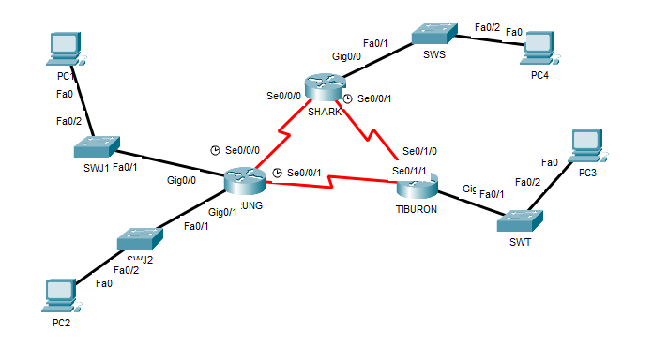

LAB INFORMATION
Here is some basic information for the lab. The network address given is 172.18.110.0/23.
Table 1

Device | Subnetwork | Usable Hosts
JERUNG | LAN1 | 20
 | LAN2 | 30
SHARK | LAN | 60
TIBURON | LAN | 50
Connections | JERUNG-SHARK | 2
 | JERUNG-TIBURON | 2
 | SHARK-TIBURON | 2

Usable High - Low
Table 2

# | Device  Name | Interface | IP Address | Subnet Mask | Gateway
1 | JERUNG | Se0/0/0 | 172.18.110.193 | 255.255.255.252 | -
2 |  | Se0/0/1 | 172.18.110.197 | 255.255.255.252 | -
3 |  | G0/0 | 172.18.110.161 | 255.255.255.224 | -
4 |  | G0/1 | 172.18.110.129 | 255.255.255.224 | -
5 | TIBURON | Se0/1/1 | 172.18.110.198 | 255.255.255.252 | -
6 |  | Se0/1/0 | 172.18.110.202 | 255.255.255.252 | -
7 |  | G0/0 | 172.18.110.65 | 255.255.255.192 | -
8 | SHARK | Se0/0/0 | 172.18.110.194 | 255.255.255.252 | -
9 |  | Se0/0/1 | 172.18.110.201 | 255.255.255.252 | -
10 |  | G0/0 | 172.18.110.1 | 255.255.255.192 | -
11 | PC1 | - | 172.18.110.190 | 255.255.255.224 | 172.18.110.161
12 | PC2 | - | 172.18.110.158 | 255.255.255.224 | 172.18.110.129
13 | PC3 | - | 172.18.110.126 | 255.255.255.192 | 172.18.110.65
14 | PC4 | - | 172.18.110.62 | 255.255.255.192 | 172.18.110.1

LAB TASKS

Task 1 – IP Addressing
- Given the network address of the organisation and the basic information provided in both Tables 1 and 2. Show your workings here and complete Table 2 with the correct information. PCs will be given the last usable address of the subnetwork.

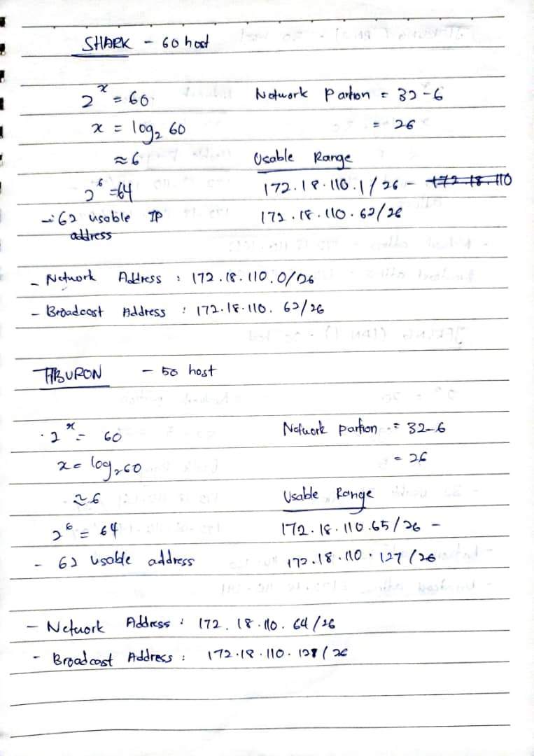
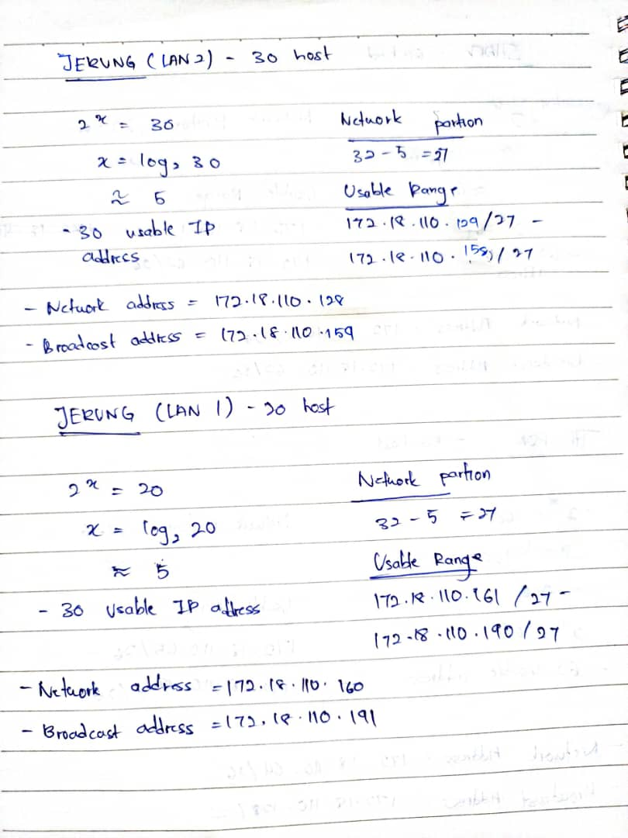
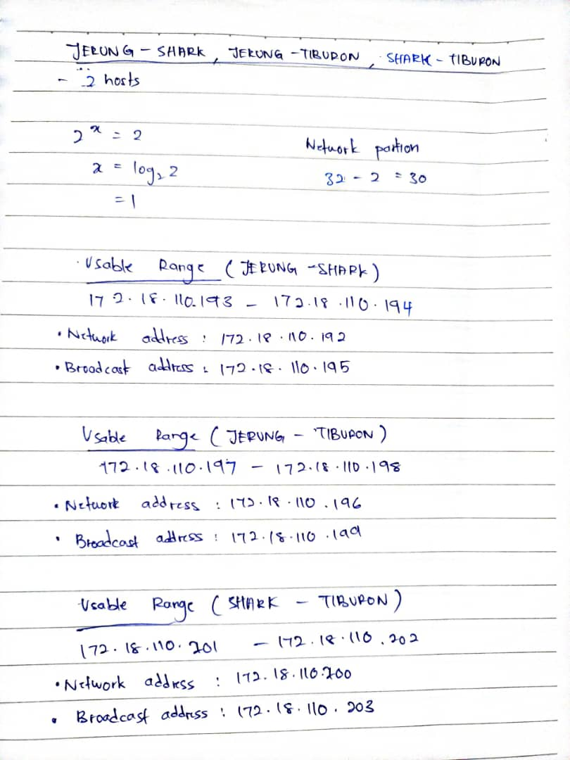

- Using the IP addresses calculated, configure the devices with the appropriate information.

Task 2 – Routing Table
- Paste the current routing table of each router here. There are 2 ways to this – via CLI and via Packet Tracer (PT) tool. Use both ways to show the routing table of all the routers.
  - CLI
    - Click on a router. In the prompt, type show ip route. The routing table of the router will be shown, as shown in Figure A.
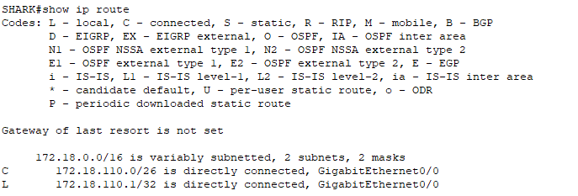
Figure A
JERUNG
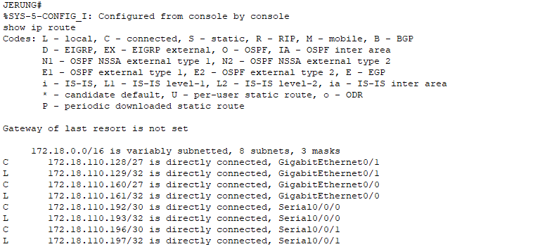

SHARK
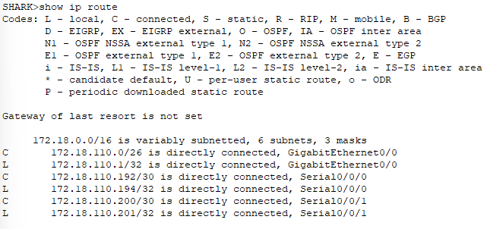
TIBURON
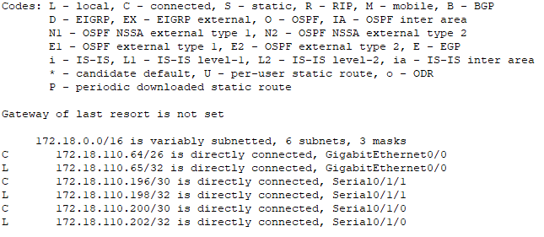

  - PT tool
    - Click on the magnifying glass (shown in Figure B), then click on a router, then choose Routing Table. A sample of the result is shown in Figure C.
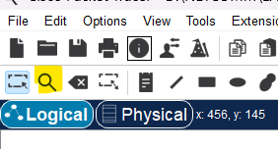
Figure B
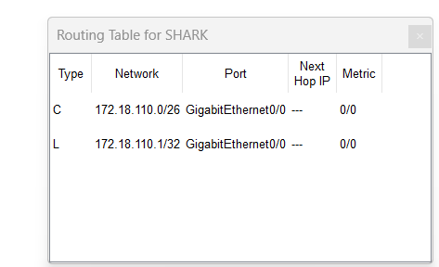
Figure C
JERUNG
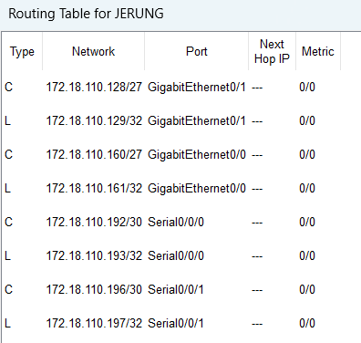
SHARK

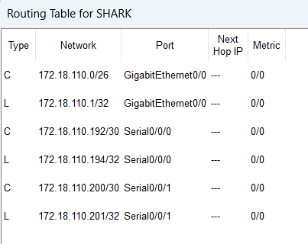
TIBURON

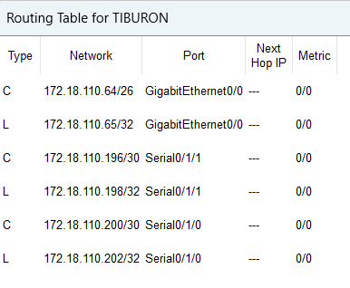
- Try to ping PC2 from PC1, paste the results here.
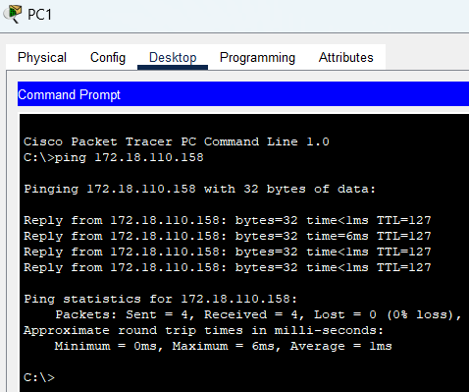
- Try to ping PC4 from PC1, paste the results here.
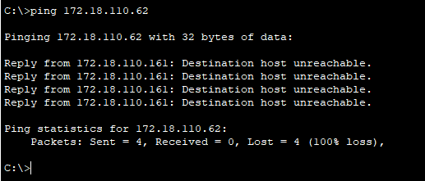
- Explain the reason(s) behind the results.
Because router JERUNG doesn’t routes with the SHARK where the PC4 at.
- What needs to be done to ensure all PCs can ping each other successfully?
All PCs need to be route

Task 2 – Routing Configuration
- Let’s start by opening the routing table (using the PT tool) for TIBURON and JERUNG. This is done to show changes to the routing table as configurations are made.
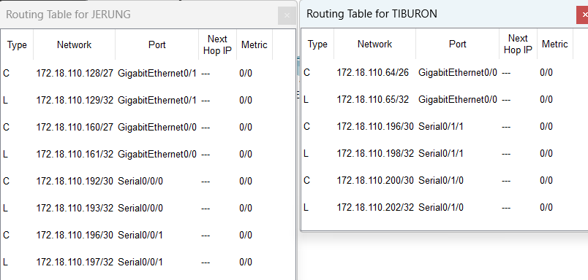
Figure D
- In router JERUNG, configure the RIP routing protocol as shown in Figure E.
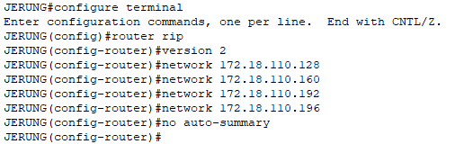
Figure E
  - What can you say about the addresses used in the ‘network’ instructions in Figure E?
- The addresses in the network instructions are private IP addresses from the 172.16.0.0/12 range, representing specific subnets configured for custom routing using RIP version 2, with no auto-summary ensuring classless routing without summarization to the main network.

- Then configure RIP in TIBURON. All are similar except use the network address. Use the instructions as shown below.
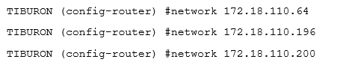
- As you may have seen, there are changes in the routing tables of both TIBURON and JERUNG. Paste a copy of these routing tables here.

JERUNG
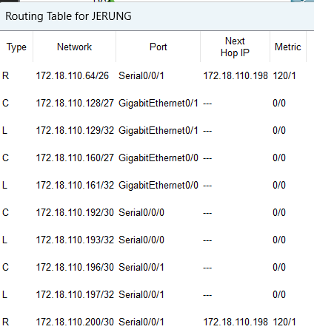

TIBURON
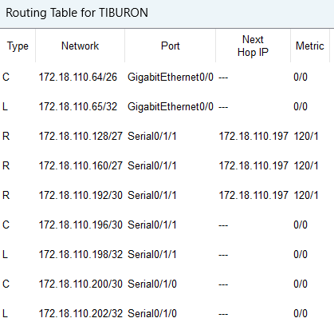

  - What are the changes seen in TIBURON?
- TIBURON's routing table now includes RIP-learned routes for the subnets 172.18.110.128/27, 172.18.110.160/27, and 172.18.110.192/30, with classless routing enabled due to the no auto-summary configuration.

  - What are the Networks with type R in TIBURON and JERUNG?
- TIBURON: 172.18.110.128/27, 172.18.110.160/27. 172.18.110.190/30
- JERUNG: 172.18.110.64/26, 172.18.110.200/30

  - Ping PC3 from PC1. Was it successful?
- Yes
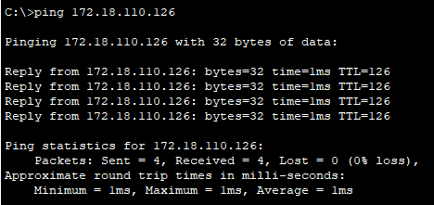
  - Ping PC4 from PC1. Was it successful?
- No
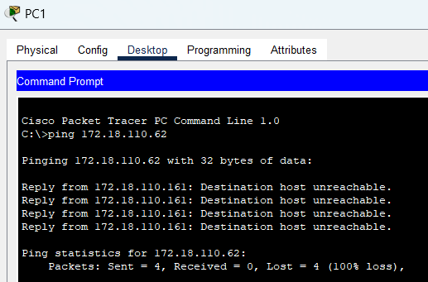
  - Explain the reasons for your answer.
- The ping to PC4 failed because its subnet (172.18.110.62) is not being advertised by TIBURON or SHARK through RIP, or there is a misconfiguration or broken connection between SHARK, SWS, and PC4.

  - Continue with configuration of RIP in SHARK. Paste your configurations here.

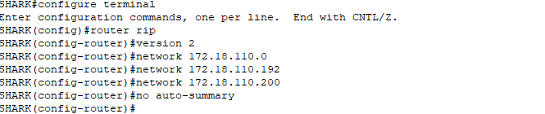

  - Open router SHARK’s routing table and paste here.
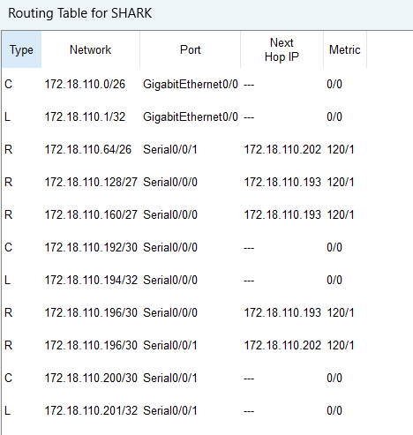
  - Try to ping from PC4 to all other PCs in the topology. *Note: Try to ping at least twice to get best results.
PC | Ping result
1 | Reply, success (average: 6ms)
2 | Reply, success (average: 8ms)
3 | Reply, success (average: 8ms)

Task 3 – Routing Update
- Let’s try a little experiment. Change the IP addresses of router TIBURON interface G0/0 to 192.168.1.1/24.
  - This means that the subnet has changed. Find the new Network address of this subnet. Network Address is: 192.168.1.0/24
  - As this change happens, PC3 must also have different IP address, subnet mask and gateway address. What will it be?
PC3 | Info
IP address | 192.168.1.254
Subnet Mask | 255.255.255.0
Gateway Address | 192.168.1.1

  - After this change, can PC4 and PC1 ping PC3?
- Both PC4 and PC1 fail to ping PC3
PC1
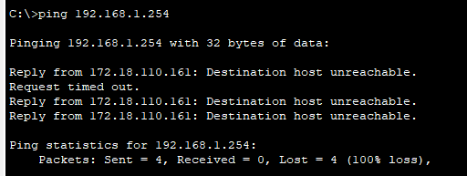

PC4
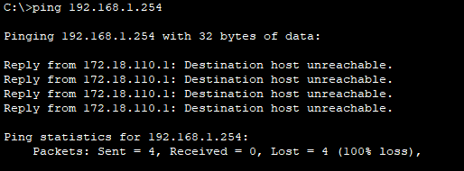
  - Copy and paste the routing tables for both SHARK and TIBURON here.
SHARK
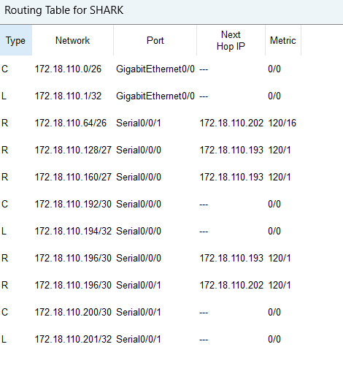

TIBURON
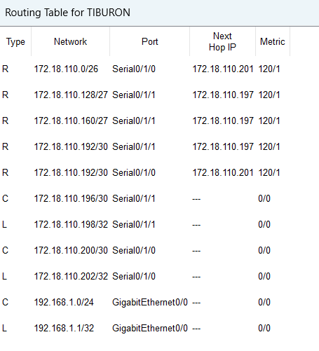
  - Referring to the routing table, explain your findings.
- Both routers TIBURON and SHARK does not have the routing protocols
  - What is your next move to ensure end-to-end connectivity (i.e. all PCs can ping each other successfully)?
- Update the routing protocols (RIP or static routes) on both SHARK and TIBURON to include the new subnet.
  - Show your configurations in TIBURON to ensure end-to-end connectivity.
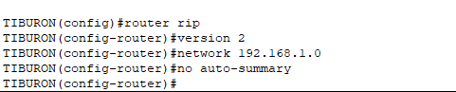
  - To ensure end-to-end connectivity, ping to all the PCs from PC3.
PC | Ping result
1 | Reply (Success)
2 | Reply (Success)
4 | Reply (Success)

REFLECTION
What have you learned in this task?
By doing every task in the file, I am able to learn everything about subnetting, ip addressing, routing protocols like RIP. So I will be able to design subnetting, configure devices with relevant IP address, and ensure the end-to-end connectivity in the network. The second is that observing routing behaviour and adjusting routing tables will provide insight into how router communication about routes and how this communication is modified as the network topology changes. So, I can to practice its connectivity issue troubleshooting, configuration updates and efficient network communication. This hands-on experience strengthens my skills in designing, implementing, and managing routed networks in real-world scenarios.

